Java Object-Oriented Programming Experimental Report
NO: Experiment 10 Experiment name：Exceptions
Student ID | 1607052230 | Name | 邱冠霖 | Class |  | 16软工1班
Location | 实1-218 | Teacher | 唐朝辉 | Time |  | 20180525
1.Experimental purposes and requirements
1.1 Exceptions
2.Experimental equipment (environment) and requirements
2.1 Eclipse
2.2 Window XP
3.Lab Exercises(Please see Lab Manual)
3.1 Exceptions Aren’t Always Errors
3.2 Placing Exception Handlers (choose to do)
3.3 Throwing Exceptions(choose to do)
3.4 Copying a File(choose to do)
3.5 Reading from and Writing to Text Files(choose to do)
3.6 A Movable Circle(choose to do)
3.7 A Currency Converter(choose to do)
3.8 Listing Prime Numbers(choose to do)
4.Experimental results and data processing

5.Analysis and discussion
没有遇到什么问题，源代码都放在github上，欢迎讨论
https://github.com/kong1414/JavaLesson.git
6.Teacher Reviews  Signature：  Date： |  |  |  |  | Score:

Experimental Report List
1 Exercises
1) Source code list
package chapter10;
import chapter09.p1.Executive;
import java.util.Scanner;
/**
* @Description:
* @Author: QiuGuanLin
* @Date: 2018/5/25 15:05
*/
public class CountLetters {
public static void main(String[] args) {
int[] counts = new int[26];
Scanner scan = new Scanner(System.in);
//get word from user
System.out.print("Enter a single word (letters only, please): ");
String word = scan.nextLine();
//convert to all upper case
word = word.toUpperCase();
//count frequency of each letter in string
for (int i = 0; i < word.length(); i++) {
try {
counts[word.charAt(i) - 'A']++;
} catch (Exception e) {
System.out.println("Not a letter");
}
}
//print frequencies
System.out.println();
for (int i = 0; i < counts.length; i++) {
if (counts[i] != 0) {
System.out.println((char) (i + 'A') + ": " + counts[i]);
}
}
}
}

2) Results data processing
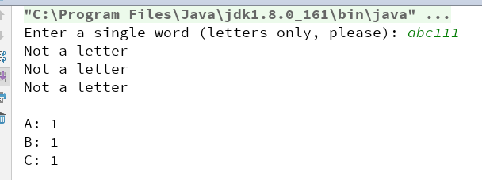

3) Answer questions

4)Error Analysis and Discussion

2 Throwing Exceptions
1) Source code list
package chapter10;
import java.util.Scanner;
/**
* @Description:
* @Author: QiuGuanLin
* @Date: 2018/5/25 15:58
*/
public class Factorials {
public static void main(String[] args) {
String keepGoing = "y";
Scanner scan = new Scanner(System.in);
while (keepGoing.equals("y") || keepGoing.equals("Y")) {
System.out.print("Enter an integer: ");
int val = scan.nextInt();
try {
System.out.println("Factorial(" + val + ") = " + MathUtils.factorial(val));
} catch (IllegalArgumentException e) {
e.printStackTrace();
}
System.out.print("Another factorial? (y/n) ");
keepGoing = scan.next();
}
}
}

package chapter10;
/**
* @Description:
* @Author: QiuGuanLin
* @Date: 2018/5/25 15:59
*/
public class MathUtils {
//----------------------------------------------
// Returns the factorial of the argument given
// ---------------------------------------------
public static int factorial(int n) {
int fac = 1;
IllegalArgumentException ill = new IllegalArgumentException();
if (n > 16 || n < 0) {
throw ill;
}
for (int i = n; i > 0; i--) {
fac *= i;
}
return fac;
}
}

2) Results data processing
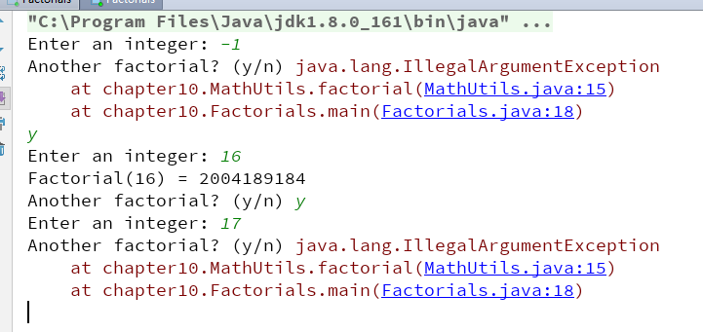

3) Answer questions

4)Error Analysis and Discussion

